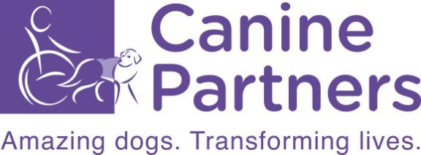

GIFT AID FORM

Gift Aid is a simple way to make your donation go even further. If your donation is eligible, Canine Partners can claim an extra 25% from HMRC.

That means for every £1 you give, it is worth £1.25 to Canine Partners at no extra cost to you. These extra funds mean we can train more of our amazing dogs and transform more lives.

Your details – Please complete in BLOCK CAPITALS

Title………… Forename(s)…………….…………………… Surname ………………………………….……………………..

Address…………………………………………………………………………………….………………………………………..

……………………………………………………………………………………..…………………………………………………

………………………………………………………….…….… Postcode……………………………………………………….

Email:………………………………………………………………………………………..………………………………………

(Office Use Only) Supporter Reference Number……………………………………………...…………………………………

Keeping in touch:
Canine Partners respect your personal information and your privacy and we will not sell or share your data with other organisations.
We may use your contact details and information on how you support or engage with us to provide information we think you will find interesting. To find out more about how we manage your personal data, please read our Privacy Policy at caninepartners.org.uk/privacy
To hear about our life-transforming work and ways to donate and raise funds to support us, please let us know how we can contact you: Email Text
You can update how you hear from us, including telling us if you do not wish to receive occasional direct mail or calls from Canine Partners by visiting caninepartners.org.uk/keepintouch or by calling 01730 716 010.

Making your donation go further

I am a UK taxpayer and I want Canine Partners to treat all donations I have made today, in the past four years and in the future as Gift Aid donations until I notify you otherwise. I understand that if I pay less Income Tax and/or Capital Gains Tax than the amount of Gift Aid claimed on all my donations in that tax year, it is my responsibility to pay any difference.

Signature……………………………………………………………… Date ……/……/…..

Please return this form by emailing database@caninepartners.org.uk or post it to
Canine Partners, Mill Lane, Heyshott, Midhurst, West Sussex, GU29 0ED
Please also notify us if you change your name and/or address, if you wish to cancel this declaration at any time, or if you no longer pay income and/or capital gains tax.
GA 02/19

